**UniRide**

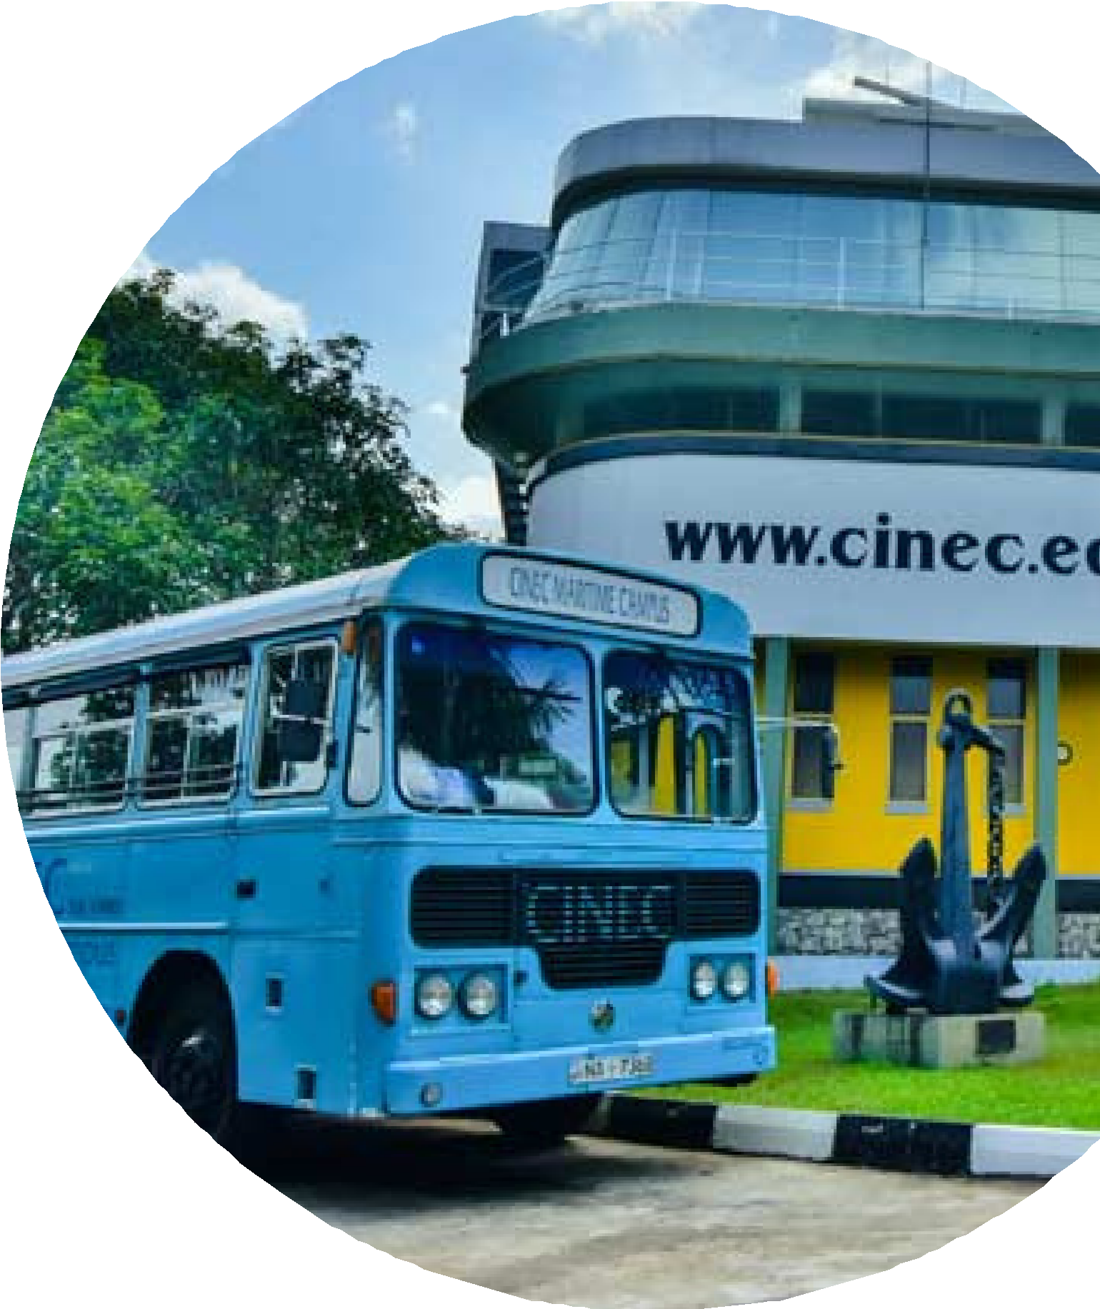

Express

Cinec Campus

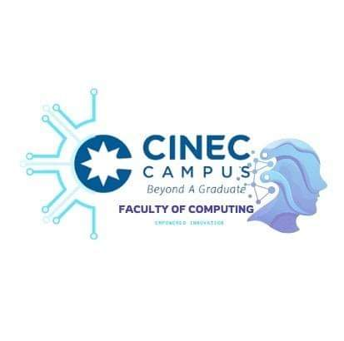

Table of Contents

**problem statement and Introduction** 3

**Objectives** 3

• **Simplify Ticket Booking** 3

• **QR-Code System** 4

• **Live Location Tracking** 4

• **Driver notification System** 5

• **Ticket Deadline Notifications/ My profile** 5

• **User Registration and Login** 6

• **Admin Dashboard** 6

• **Notification System** 6

• **System Maintenance and Updates** 6

**Target Audience** 6

**Benefits** 7

**Benefits for Passengers and drivers** 7

**Benefits for the Campus** 7

**Technical Requirements** 7

**Project Timeline** 8

**Sustainability and Future Scalability** 8

Conclusion 9

Smart Campus Transit: Implementing the Campus transport with Online Ticketing System

**Team Members:**

* **A.P.M.Amarasinghe (Team Leader) – M20020208003**
* **H.M.S.Umayangana – F020000301006**
* **W.M.P.Mathsara – M20011023004**
* **P.K.P.I.K.Pallawela – F20030406003**

# **problem statement and Introduction**

In the fast-paced campus environment, students and staff need an easy way to manage their daily commutes. In the current system, a lot of time has to be spent to perform that action. It's a waste of everyone's time. Also, we observed the cases where some problems arise during the ticket inspection. We propose this to solve many problems including these problems. The "**Uni-Ride**" system is designed to solve this by making bus ticket booking more convenient and accessible to everyone. By replacing old, time-consuming methods, this system ensures that the university community can plan their journeys with minimal effort. And many additional features are included in this.

# **Objectives**

## **Simplify Ticket Booking**

Provide a user-friendly interface for students and staff to book bus tickets online. This is the interface in that web page;

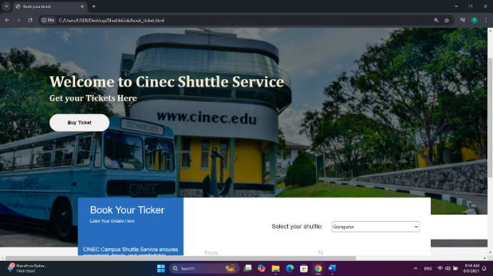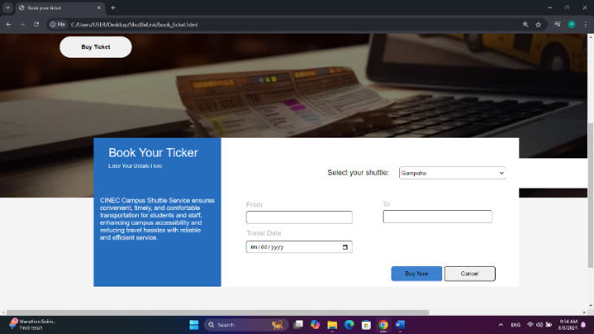

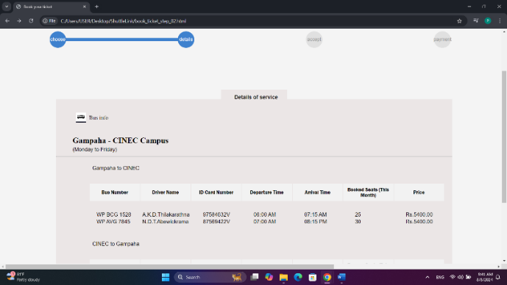

## **QR-Code System**

A QR code system for check ticket and verify. Checker can scan passenger’s digital ticket QR and verify that. This ensures quick, verification, improving efficiency and reducing fraud.

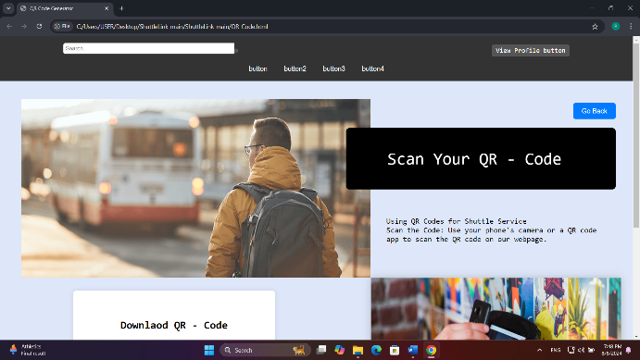

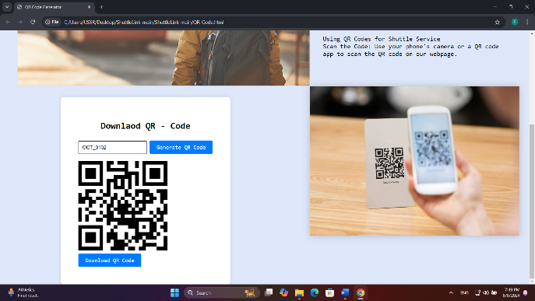

## **Live Location Tracking**

A live location tracking system for online bus service allows passengers to view the real-time location of their bus, ensuring they can track its progress and plan their journey efficiently.

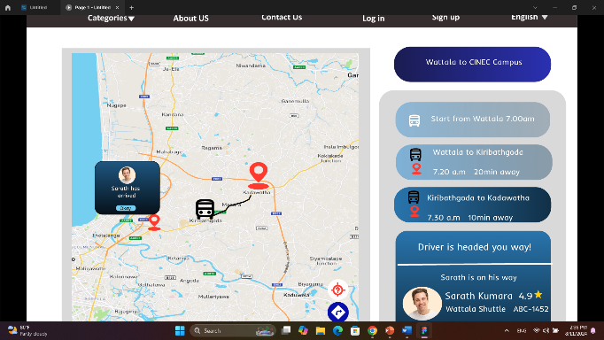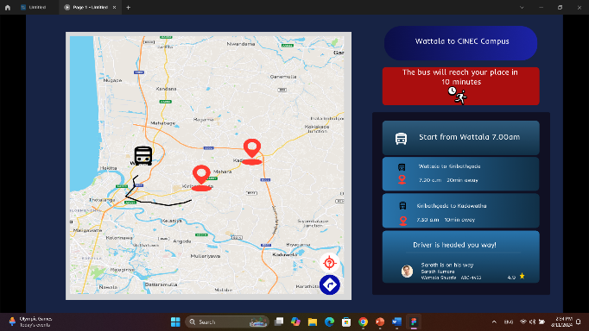

## **Driver notification and location**

The driver notification system helps bus drivers by providing real-time alerts about passengers waiting on the road. In that page show the distance to passenger and displays their location on a map with detailed information, ensuring drivers can efficiently plan stops and improve overall service reliability.

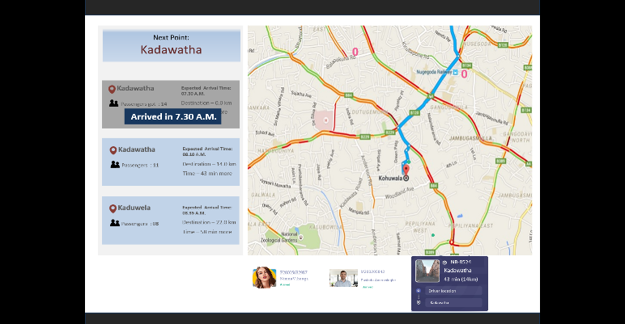

## 

## **Ticket Deadline Notifications/ My profile**

The ticket deadline notification system sends reminders to passengers as the ticket expiration date approaches, including details about the deadline. It provides a summary of key information, such as the end-of-month cutoff date, ensuring passengers stay informed and avoid missing their ticket deadlines.

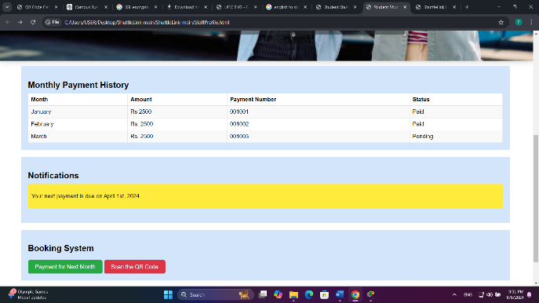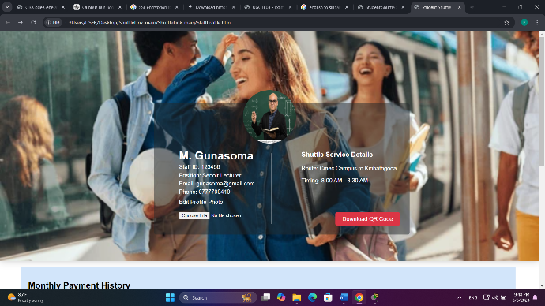

* **User Registration and Login**

A secure registration and login system for students, faculty, and staff to create accounts.

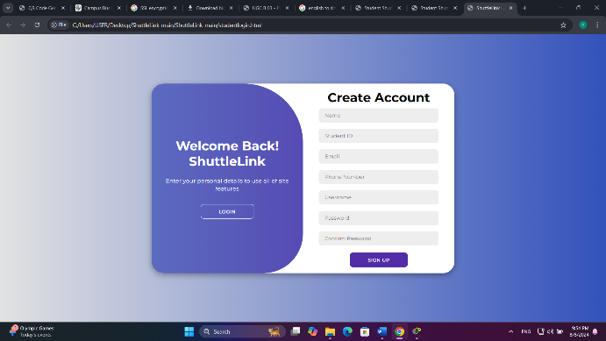

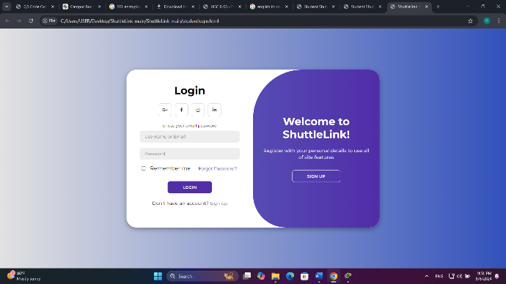

* **Admin Dashboard**

A backend dashboard for university administrators to manage bus schedules, track bookings, and generate reports etc.

* **Notification System**

Automated notifications via email or SMS to inform users of booking confirmations, reminders, and bus delays.

## **System Maintenance and Updates**

**Regular Updates**: Planed for periodic system updates to add new features, fix bugs, and enhance security.

**Maintenance Schedule**: Establish a schedule for routine maintenance and communicate it to users to minimize disruption.

# **Target Audience**

The system is for **students, and staff who need to use campus buses.** It helps them easily book and manage their bus tickets online, making their travel on campus simpler and more convenient.

# **Benefits**

## **Benefits for Passengers and drivers**

* Can manage bookings quickly online.
  + - * Access real-time updates and bus schedules for better planning.
* Easily book and pay for tickets from any device.
* Less paperwork and manual ticket handling, leading to smoother operations.
* Access up-to-date schedules and passenger counts for better route planning.
* QR code scanning for tickets helps speed up boarding and reduces contact, improving safety.

## **Benefits for the Campus**

* Collect and analyze data on bus usage, peak times, and passenger preferences to improve service planning.
* Easily scale the system to accommodate changes in bus routes or increased passenger numbers.
* Automated notifications and alerts improve communication with passengers regarding delays and updates.

# **Technical Requirements**

* **Platform -** Web-based application using React JS,HTML,CSS etc.
* **Database -** Secure database to manage user data, bookings, and schedules using MySQL.
* **User Interface -** Intuitive, easy-to-navigate interface designed for a positive user experience.

# **Project Timeline**

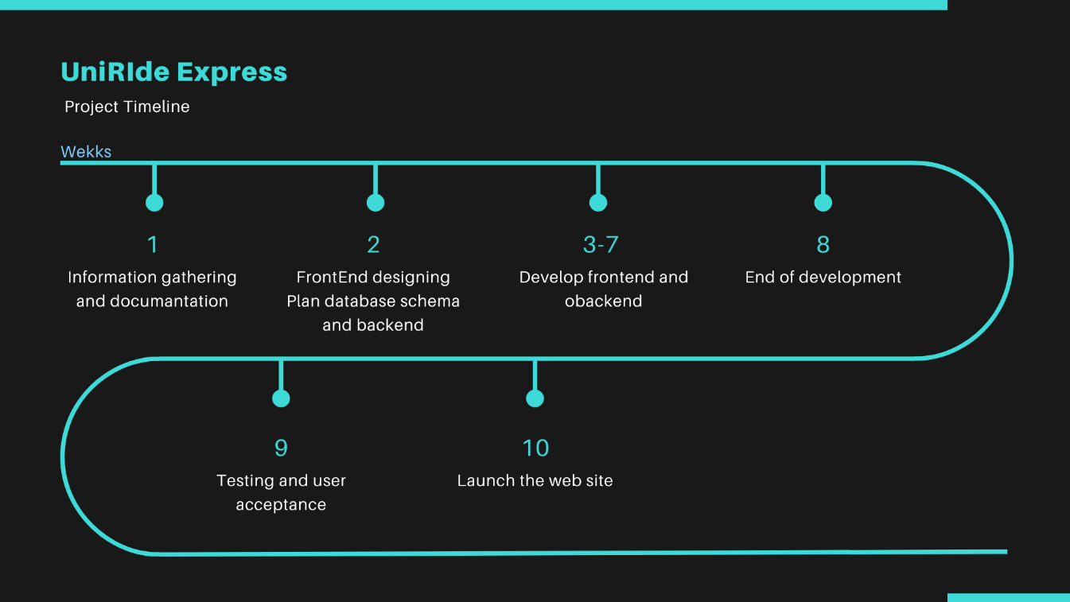

# **Sustainability and Future Scalability**

The UniRide Express system supports sustainability by replacing paper tickets with digital ones, helping to reduce waste. It encourages more students and staff to use public transportation, which lowers the campus's overall carbon footprint. The system is designed to be energy-efficient and will receive regular updates to ensure long-term functionality. By making bus travel more convenient, the system aligns with the university’s environmental goals and contributes to a more sustainable and eco-friendly campus.

The future of this includes adding new features like more payment options and better route planning. We’ll also develop a mobile app to make it easier for users to track buses and manage tickets on their phones. The system will expand to accommodate more users and could potentially be implemented on other campuses. We’ll continue to improve the system based on feedback, incorporate new technologies, and maintain strong security measures to keep it up-to-date and reliable.

# Conclusion

This system is a smart and practical solution designed to make transportation easier for everyone at the university. It offers a simple, eco-friendly way to book bus tickets, improving the daily commute for students, faculty, and staff. The system is not only useful now but is also set to grow and improve with new features and technology, making sure it stays helpful as the university expands. This proposal highlights a project that meets current needs while also supporting the university’s goals for innovation and sustainability in the future. Thank you